**Videoconference:**

India Virtual Collaboration Team (IVCT) provides Videoconferencing as one of its services. In this services we provide end to end services for shared VC room which are supported by ISA. In most of the facilities we have 1 shared VC room which are chargeable.

**Booking:**

For utilizing shared VC rooms organizer needs to book VC room through Outlook using MS Teams.

**Cost:**

Shared VC rooms are charged with **INR 1700/- Per Hour Per Room.**

**Policy:**

Scheduler needs to cancel/modify booking invite used at the time of booking needs to cancel original invite from his/her calendar 24 hours prior to start of VC meeting to avoid charges.

**Offsite Videoconference Event:**

**IVCT also provides offsite VC devices by configuring our Mobile VC Kit in any Hotels, Resorts etc with our Accenture offices.**

**Cost:**

|  |  |
| --- | --- |
| **Description** | **Charges** |
| Mobile Webcast Kit | **$76** |
| Engineer & Travelling | **Man Hours in MyTe & Actuals Travel Cost** |

**Mobile Teams Kit:**

|  |  |
| --- | --- |
| **Description** | **Charges** |
| Mobile Teams Kit | **$631** |
| Engineer & Travelling | **Man Hours in MyTe & Actuals Travel Cost** |

**Teams Live Event:-**

|  |  |  |  |  |
| --- | --- | --- | --- | --- |
|  | **STANDARD** | **MULTI SPEAKER LAYOUT** | **2D OVERLAY** | **3D** |
| **Timelines** | 7 Days* | 7-10 Days* | 10-12 Days* | 12-15 Days* |
| **Base Cost** | INR 830/- Per Hour Per FTE | INR 830/- Per Hour Per FTE | INR 830/- Per Hour Per FTE | INR 830/- Per Hour Per FTE |
| **Additional Cost** | NA | $765 | $1,164 | $1,625 |
| **Content Sharing** | YES | YES | YES | YES |
| **Pre Recorded Video** | YES | YES | YES | YES |
| **Single Video** | YES | YES | YES | YES |
| **Multi Speaker** | NO | YES | YES | YES |
| **Background Overlay Design** | NO | NO | YES | YES |
| **External Speaker** | NO | YES | YES | YES |
| **NOTE:-** |  |  |  |  |
| **\*Depending upon slot availability** |  |  |  |  |
|  |  |  |  |  |
|  |  |  |  |  |

**Link to Raise Support Request:** [**Submit a request**](https://ts.accenture.com/sites/SMBLTSSupportTeam)

**CoE/Boardroom:**

**Our Goal is to:**

* Establish Standardize support model across India for Center of Excellence and Next generation floors.
* Provide choice to stakeholder to select SLAs based on criticality of the showcase.
* Single team to track AMCs, inventory and tech refresh.
* Enhance availability metrics.

**Scope of Work:**

* Establish Standardize support model across India for Center of Excellence and Next generation floors.
* Provide choice to stakeholder to select SLAs based on criticality of the showcase.
* Single team to track AMCs, inventory and tech refresh.
* Enhance availability metrics.

**Support Model Type / SLA:**

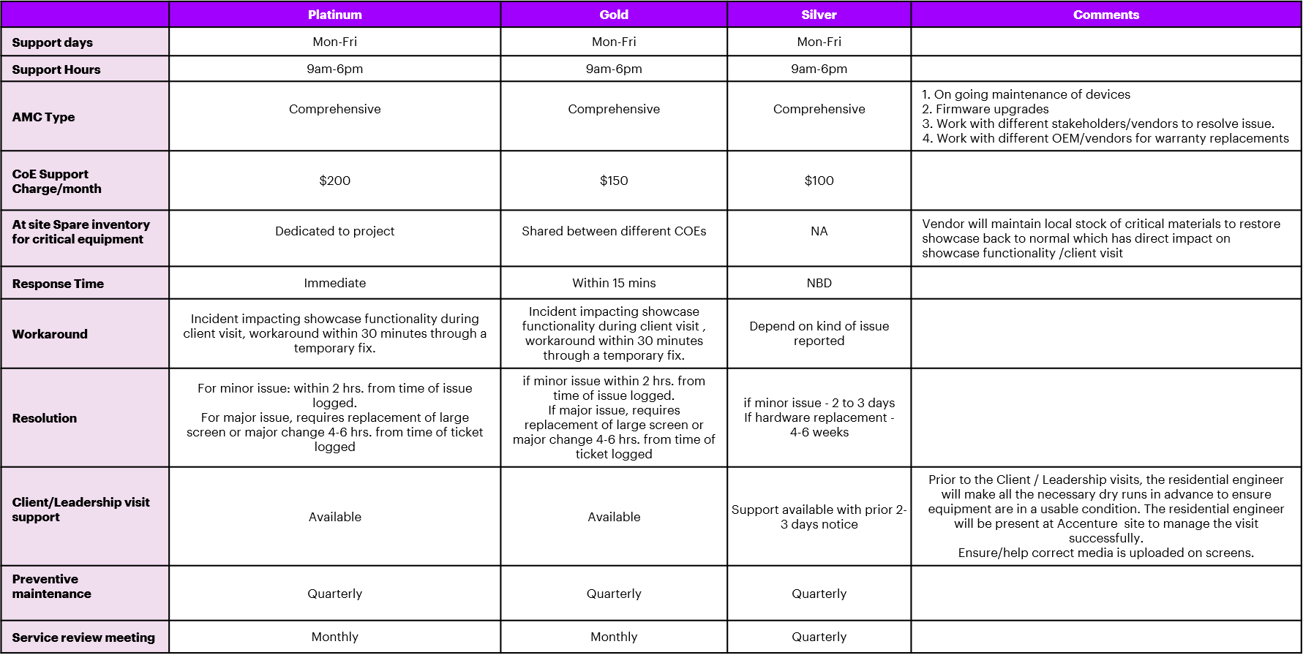

**Delivery Model:**

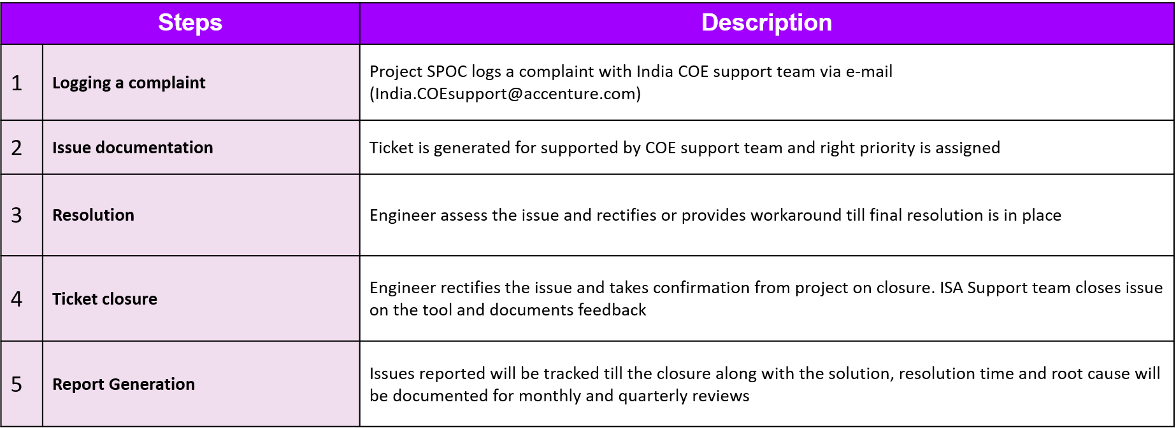

For More Information Contact us on:

Mail to: [India.COEsupport@accenture.com](mailto:India.COEsupport@accenture.com) / [India.VirtualCollaborationTeam@accenture.com/](mailto:India.VirtualCollaborationTeam@accenture.com/) [India.VCTeam@accenture.com](mailto:India.VCTeam@accenture.com)